

Memorandum

Date: October 2, 2006
Subject: Use of Commemorative Signs on Multi-Routes

Original signed by:
From: Anthony T. Furst
Reply to
Attn. of: HOTO-1

Acting Director, Office of Transportation Operations

To: Mr. J. Michael Bowen (Mike)
Division Administrator (HDA-KS)
Topeka, Kansas

Thank you for your e-mail dated August 9 requesting an official interpretation on the use of commemorative signs on multi-routes such as K-177 and US-24 in Kansas and the 95th Division of the U.S. Army Highway which is carried on 3 routes (US-24, US-59, and
K-92) or the use of commemorative signs on very long routes such as the Veterans Memorial Highway which begins on US-54 at the Missouri State line and includes the city of Wichita, Kansas.

As you know, the Manual on Uniform Traffic Control Devices (MUTCD) classifies the signs addressed in your e-mail as memorial signs (see MUTCD Sections 2D.49 and 2E.08) and states, in essence, that memorial signs shall be limited to one sign at an appropriate location in each route direction. If the memorial route (e.g. Veterans Memorial Highway) and the signed route (e.g. US-24) are one in the same, regardless of the length, then only one sign in each direction is permitted. If, however, the memorial route covers more than one signed route (e.g. US-24, US-59 and K-92), then one commemorative or memorial sign may be placed at an appropriate location in each direction of each of the multiple routes.
For example you can have one sign in each direction of K-92, one sign in each direction of US-24, and one sign in each direction of US-54. We have assigned this official interpretation the following number and title: "Request No. 2-599(I)—Use of Commemorative Signs on Multi-Routes." Please refer to this number in any future correspondence.

I appreciate the opportunity to provide this information to you and hope it is helpful.
If I can provide further information or assistance, please feel free to contact
Mr. Fred Ranck of my staff at 708-283-3545.

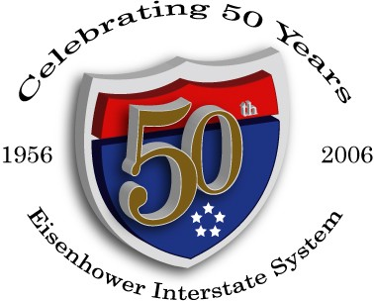

FHWA:HOTO-1:LLBrown:62192:9-18-06
Revised:ATFurst:cvan:62201:9-28-06
cc: HOTO-1 HOTO-1(LLBrown/HKalla/FRanck)
Mr. Roger Wentz, ATSSA Mr. Jim Baron, ATSSA
Chron 3408 Reader 3408

DF (official ruling file 2-599I)
/tmp/in/input.doc

